MySQL Workbench Installation: A Step-by-Step Guide

To install MySQL Workbench on Windows, the installation process is similar to other operating systems.

1. Open the MySQL website on a browser. Go to the following link: <https://www.mysql.com/downloads/>
2. Select the Downloads option.



1. Select MySQL Installer for Windows.

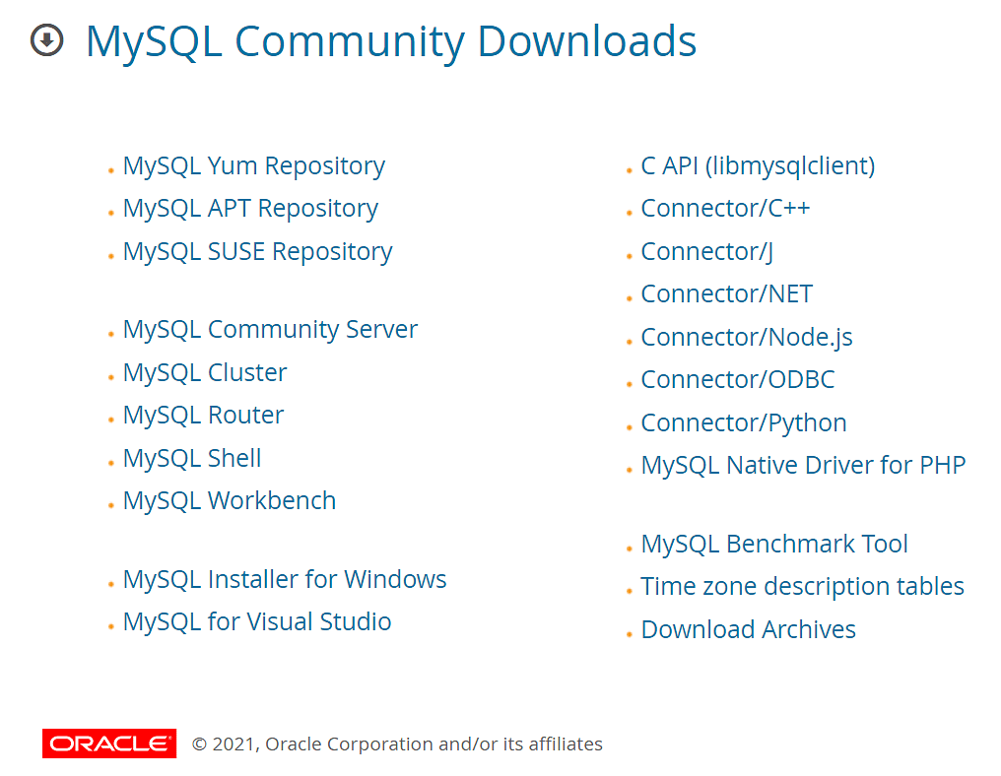

1. Choose the desired installer and click on download.

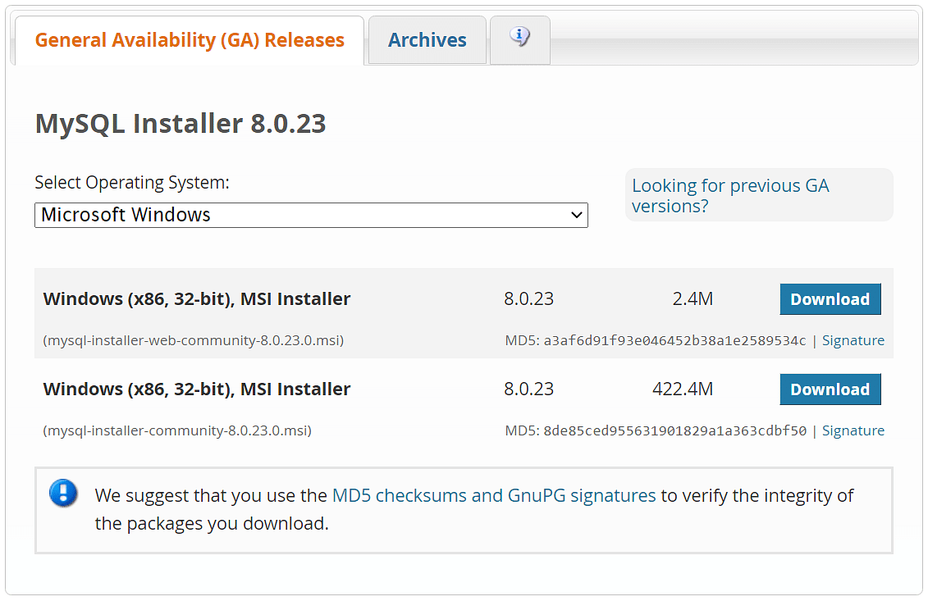

1. After the download, open the installer.

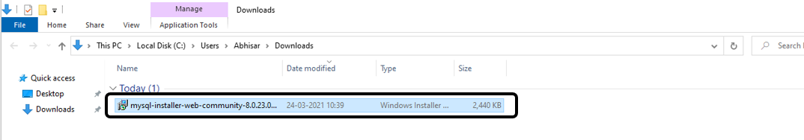

1. It will ask for permission; when it does, click Yes. The installer will then open. Now, it will ask to choose the setup type. Here, select Custom.

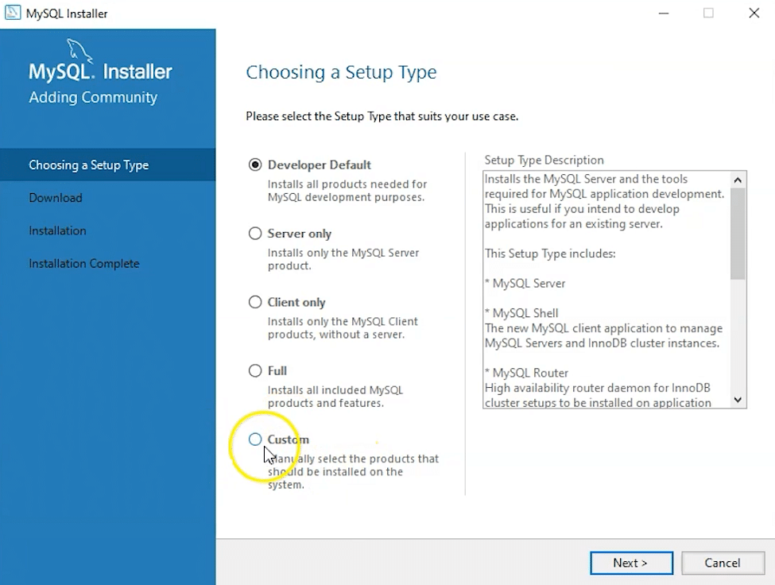

1. Click on Next. With this, you will install MySQL server, MySQL Workbench, and MySQL shell.
2. Open MySQL Servers, select the server you want to install, and move it to the  Products / Features to be installed window section. Now, expand Applications, choose MySQL Workbench and MySQL shell. Move both of them to ‘Products/Features to be installed’.

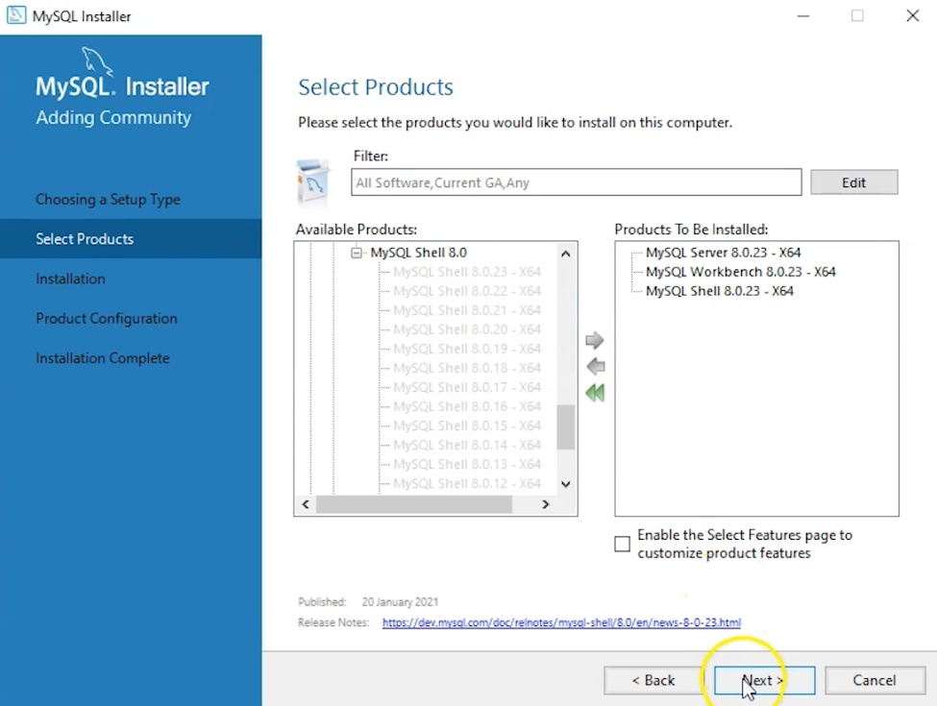

1. Click on the Next button. Now, click on the Execute button to download and install the MySQL server, MySQL Workbench, and the MySQL shell.

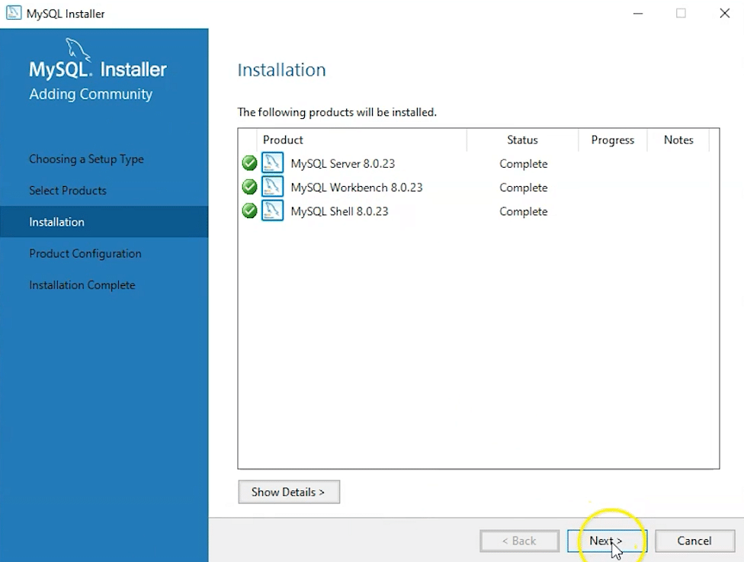

1. Once the product is ready to configure, click on Next. Under Type and Networking, go with the default settings and select Next.

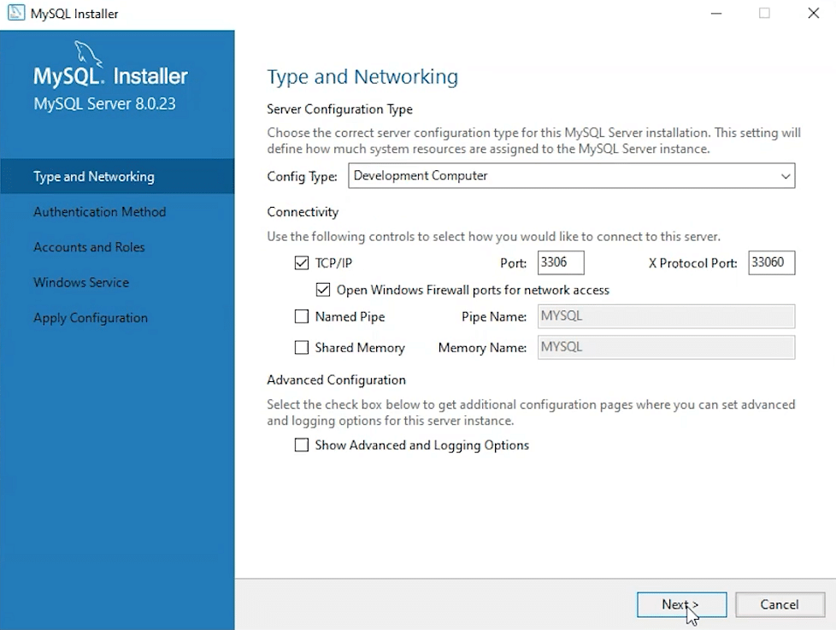

11. For authentication, use the recommended strong password encryption.

12. Set your MySQL Root password and click on next.

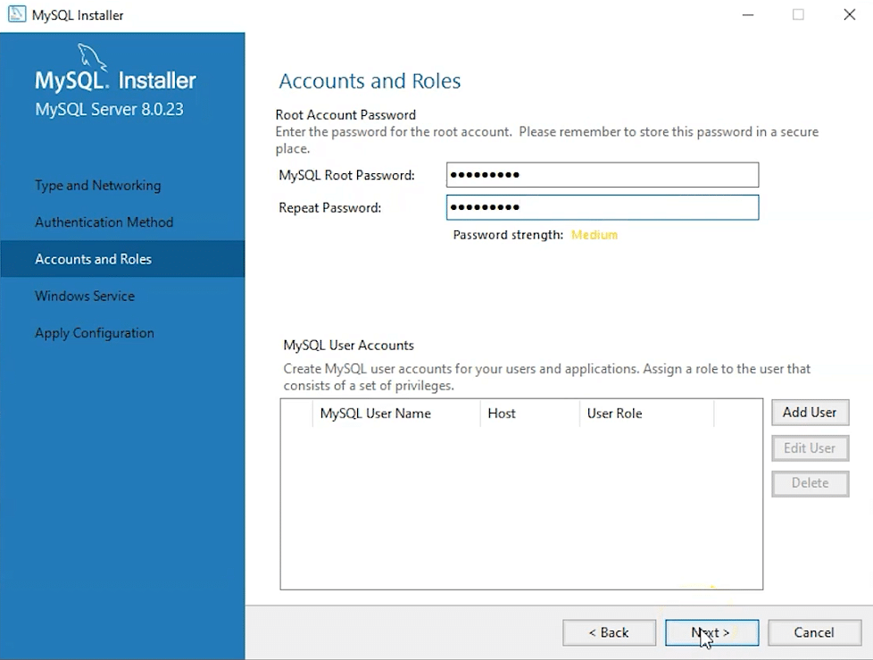

13. Go for the default windows service settings and under apply configuration, click on execute. Once the configuration is complete, click on finish.

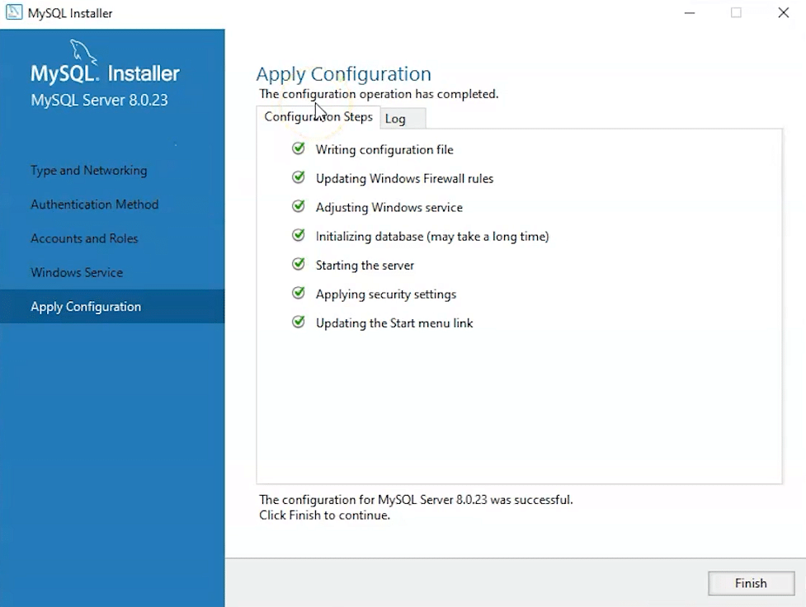

14. Complete the installation. This will now launch the MySQL Workbench and the MySQL Shell

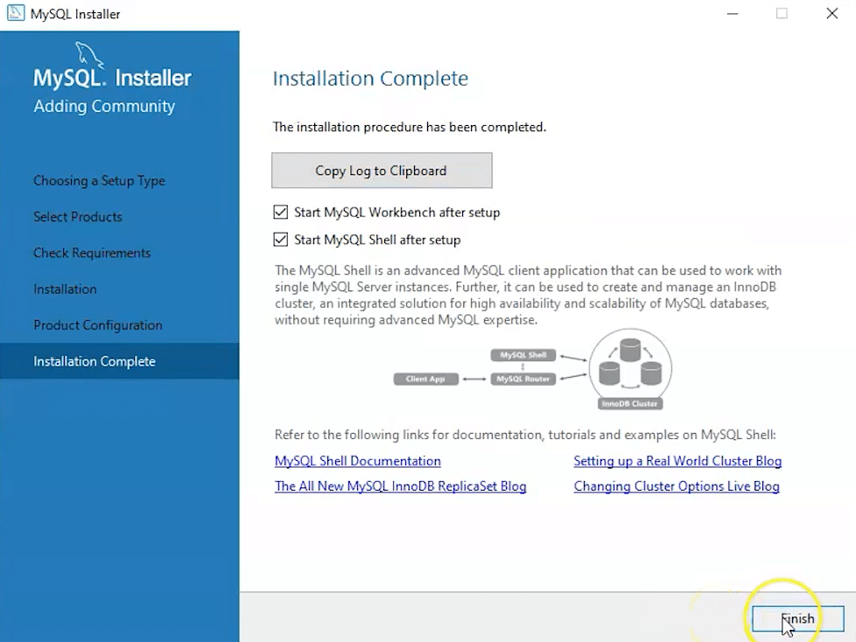

Once MySQL Workbench is installed, select the Local instance and enter the password.

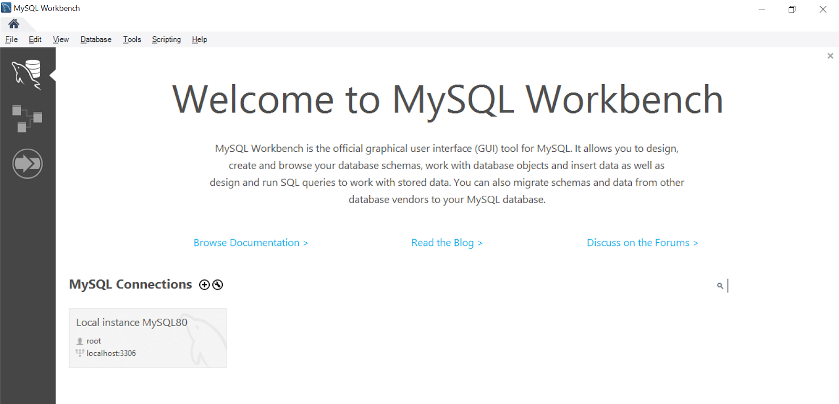

Now, you can use the MySQL query tab to write your SQL queries.